**ARYAMAN MISHRA**

**19BCE1027**

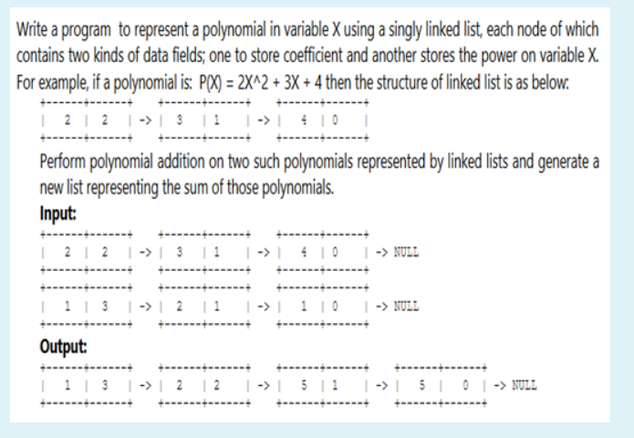

**Poly.java**

public class Poly

{

public int coeff;

public int pow_val;

public Poly next;

}

**Add.java**

import java.util.*;

public class Add

{

private Poly poly1;

private Poly poly2;

private Poly poly3;

public Add()

{

poly1 = poly2 = poly3 = null;

}

public final void addpoly()

{

Scanner sc=new Scanner(System.in);

int i;

int p;

Poly newl = null;

Poly end = null;

System.out.println("Enter highest power for x.");

p = sc.nextInt();

System.out.print("\nFirst Polynomial\n");

for (i = p; i >= 0; i--)

{

newl = new Poly();

newl.pow_val = p;

System.out.println("Enter Co-efficient for degree" + i + ":");

newl.coeff = sc.nextInt();

newl.next = null;

if (poly1 == null)

{

poly1 = newl;

}

else

{

end.next = newl;

}

end = newl;

}

System.out.println("Second Polynomial");

end = null;

for (i=p;i>=0;i--)

{

newl=new Poly();

newl.pow_val=p;

System.out.println("Enter Co-efficient for degree" + i + ":");

newl.coeff=sc.nextInt();

newl.next=null;

if (poly2==null)

{

poly2=newl;

}

else

{

end.next=newl;

}

end=newl;

}

Poly p1=poly1;

Poly p2=poly2;

end=null;

while (p1!=null && p2!=null)

{

if (p1.pow_val==p2.pow_val)

{

newl = new Poly();

newl.pow_val = p--;

newl.coeff = p1.coeff + p2.coeff;

newl.next = null;

if (poly3 == null)

{

poly3 = newl;

}

else

{

end.next = newl;

}

end = newl;

}

p1 = p1.next;

p2 = p2.next;

}

}

public final void display()

{

Poly t = poly3;

System.out.println("Answer after addition is : ");

while (t != null)

{

System.out.print(t.coeff);

System.out.print("->");

System.out.print(t.pow_val);

System.out.println();

t = t.next;

}

t = poly3;

while(t!=null)

{

System.out.print(t.coeff+"^"+t.pow_val+"+");

t = t.next;

}

System.out.println("null");

}

}

**Caller.java**

public class Caller

{

public static void main(String[] args)

{

Add obj = new Add();

obj.addpoly();

obj.display();

}

}

